Solution: Subtypes

In this lab, you will use the Entity Editor in Guidewire Studio to modify the TrainingApp data model. You will first create a subtype entity. Next, you will create an entity extension for a subtype entity.

Requirements

This lab requires that you use TrainingApp 8.0 and Guidewire Studio 8.0.

Overview

The fictitious Acme Insurance Company is your customer. Your job is to make the necessary changes to meet customer requirements. Acme wants to capture details about Property Inspectors and Legal Venues.

1. Create a subtype entity

In this exercise, you will create a subtype entity for Property Inspectors using ABPersonVendor as the supertype entity. For each new entity element, remember to set the nullok attribute to true if not specifically defined to be false. When required, add an element description and specify column parameters.

Tasks

1. Open Guidewire Studio
2. Create the ABPropInspector_Ext entity
3. In Project view, select the …\config\extensions\entity folder.
4. In the context menu, select a new Entity.
5. In the Entity dialog, create a subtype entity named ABPropInspector_Ext with the supertype of ABPersonVendor.  
   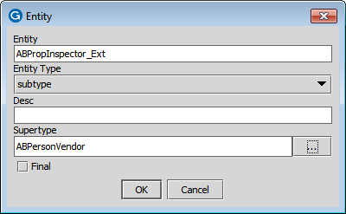
6. In the Entity Editor, add the following elements:

|  |  |  |
| --- | --- | --- |
| Element Name | Datatype | Nullok |
| InspectorLicense | A string of up to 40 characters | true |
| IsHomeInspector | A boolean value | true |
| IsCommercialInspector | A boolean value | true |

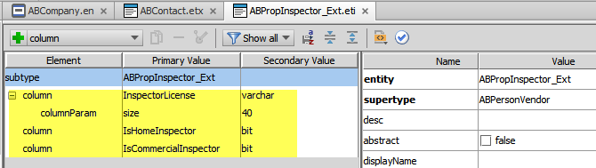

1. Validate your changes in the Entity Editor.
2. Create a subtype extension

In this exercise, you will create an entity extension of ABLegalVenue, an existing subtype entity. You will create new entity elements to capture specific information for legal venues. For each new entity element, remember to set the nullok attribute to true if not specifically defined to be false. When required, add an element description and specify column parameters.

Tasks

1. Create the ABLegalVenue entity extension
2. Navigate to ABLegalVenue.  
   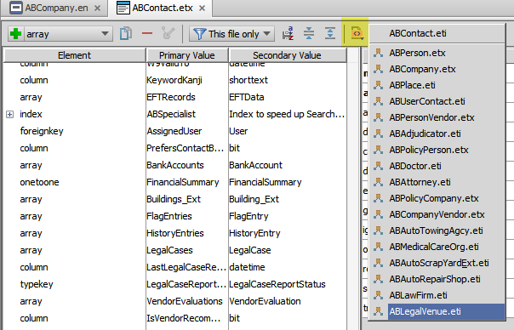
3. In the context menu, select a new Entity Extension.  
   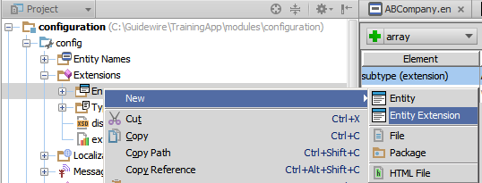
4. In the Entity Extension dialog, do NOT specify a filename suffix. Click OK.  
   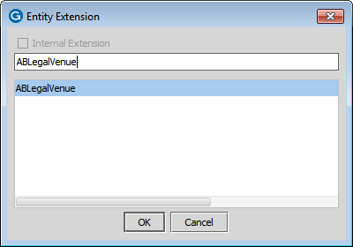
5. In the Entity Editor, add the following elements:

|  |  |  |
| --- | --- | --- |
| Element Name | Datatype | Nullok |
| HoursOfOperation_Ext | A string of up to 40 characters | true |
| OpenForNightCourt_Ext | A boolean value | true |

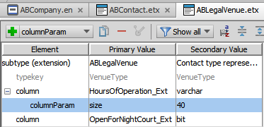

Optional verification

1. Build the data dictionary and verify your changes
2. From the bin folder, open a command window and enter the command to build the data dictionary.
3. In Windows Explorer, navigate to the data dictionary and open the data dictionary using Internet Explorer.
4. Verify the your changes to the data model for the subtype extension and subtype

Deployment

1. Deploy your changes
2. From studio, restart the server using Debug 'Server'.
3. If open, review the Messages Make window for compilation errors.
4. Review the Debug console for errors.
5. Verify that the application is running in the Debug console.

|  |  |
| --- | --- |
|  | Stop and ask your instructor to review your completed lab. |